DevOps Project Part1

**Step 1**:

Install git, docker, Java & Jenkins

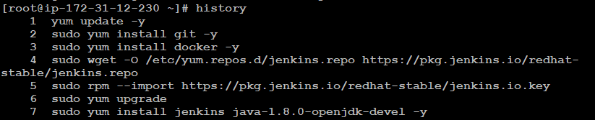



Once installation completed, login into Jenkins using secret password available in below path & install plugins

**#cat /var/lib/jenkins/secrets/initialAdminPassword**

**Step 2**:

Refer the pom.xml file where developers specified the package format, artifactId, version & application name. Also refer Dockerfile & Jenkinsfile to understand the overview of the project.

**Step 3:**

Download Maven 3.6.3 on Jenkins machine and move the binary to below path and untar the same.

**# cd /opt/apache-maven-3.6.3/**



**Step 4:**

Before creating a new job, install **Maven Integration plugin** & set the default path in Global Tool Configuration.

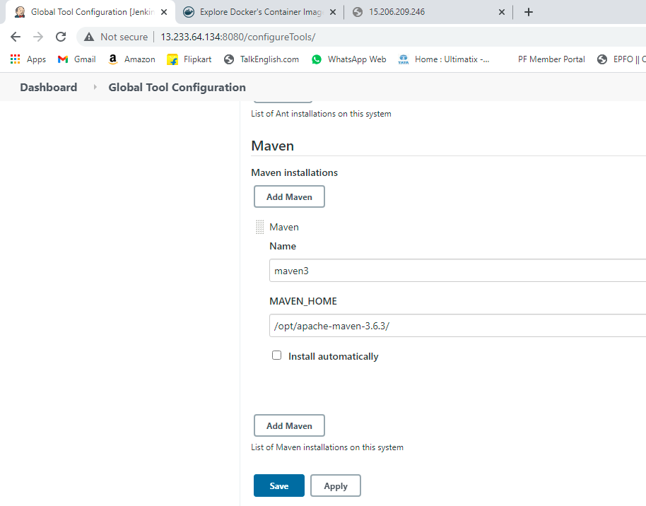

**Step 5:**

Add DockerHub credentials on **Manage Credentials**

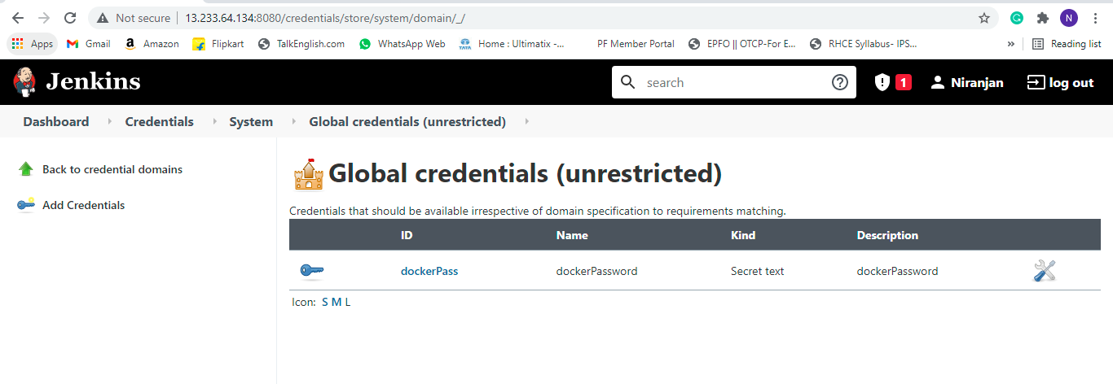

**Step 6:**

Create a Pipeline project & edit the Jenkins script file, providing my github url & my docker username & password to build successful job.

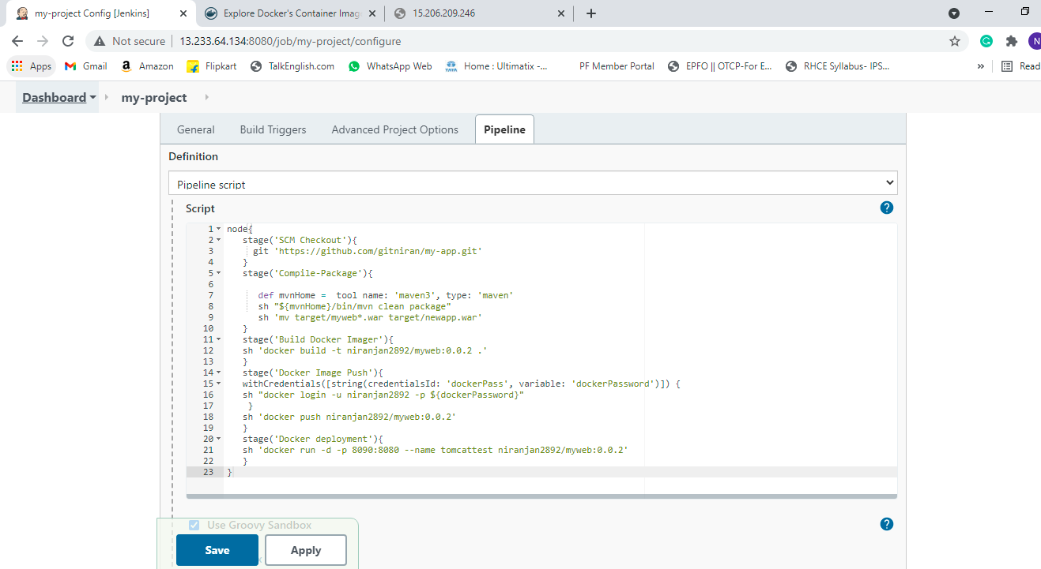

**I have faced below errors while deploying the package”**

Provide access to /var/run/**docker.sock** to clear the below error

**#chmod 777 docker.sock**

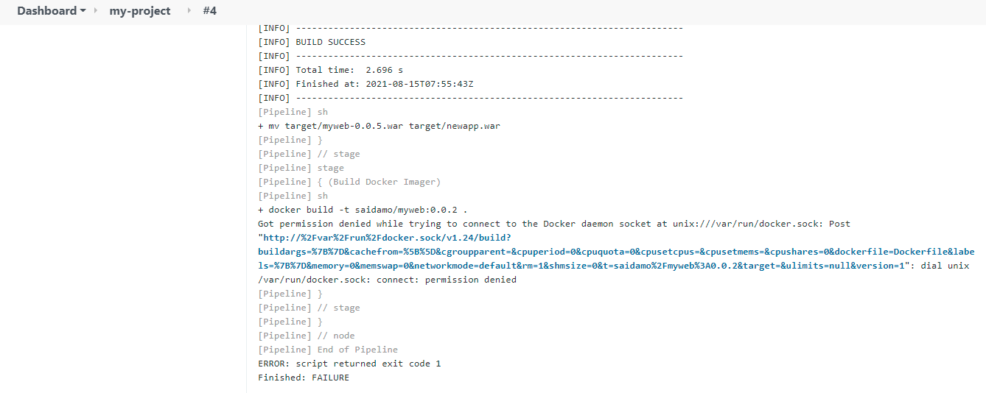

We need to change the secret text instead of username with password on Manage credentials for below error.



After correction of errors, build got successful

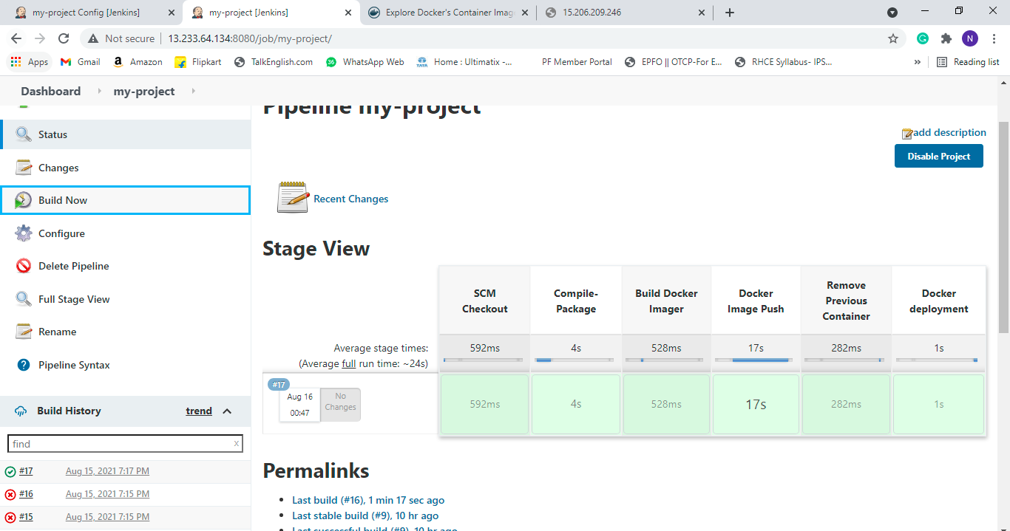

**Output:**

